姓名 | 梅健强 | 出生年月 | 1981.12 | 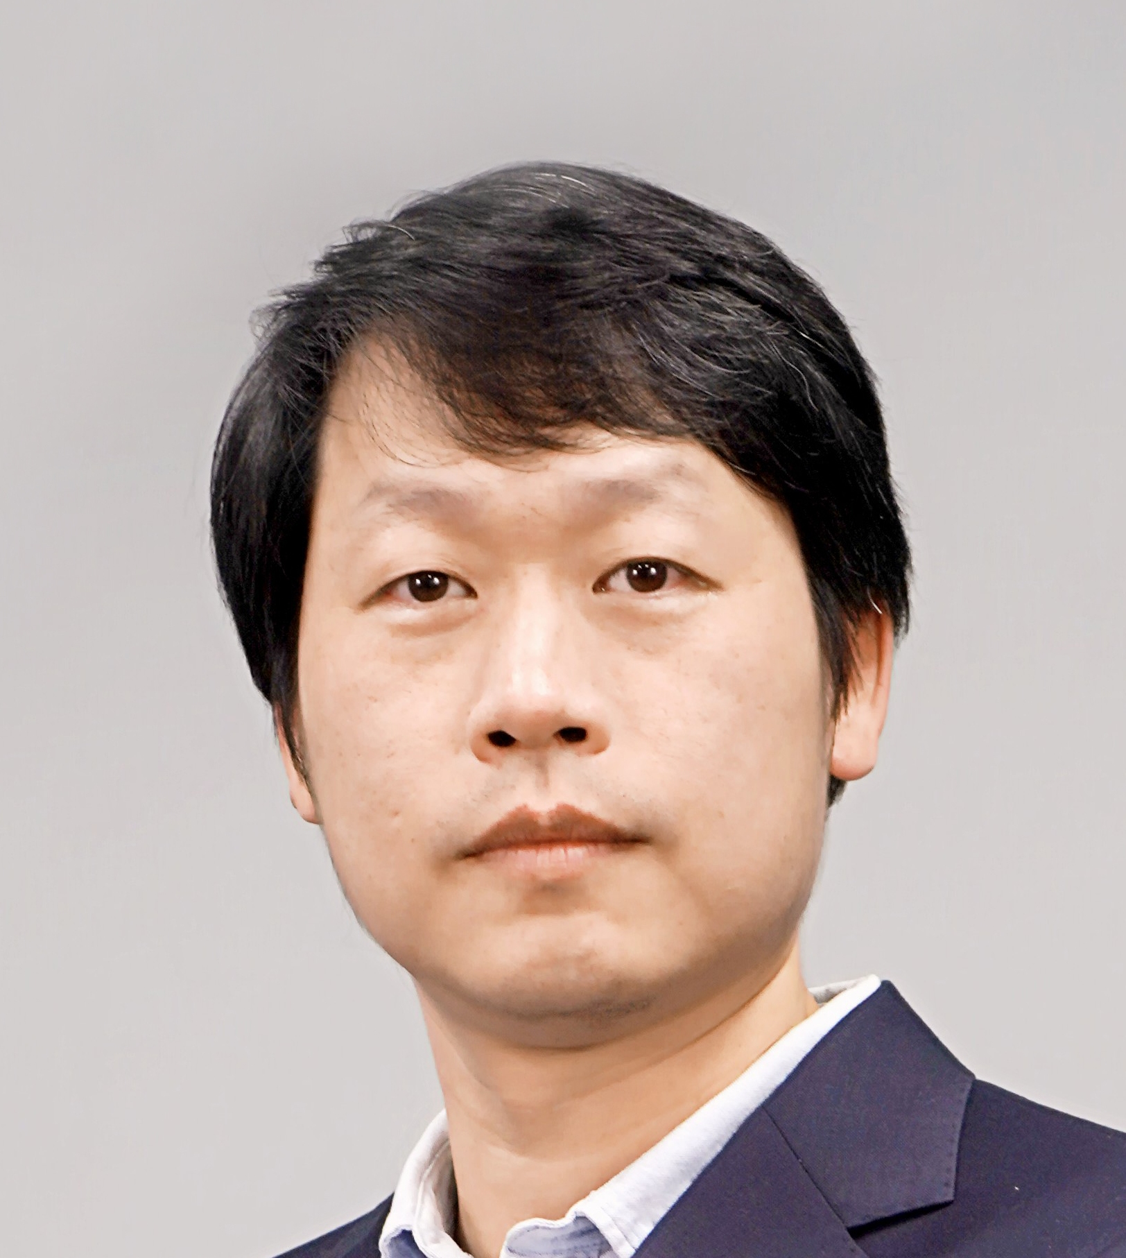
性别 | 男 | 学历学位 | 博士研究生
职称 | 讲师 | 导师类型 | 学硕、专硕
办公地点 | 机电楼228 | 所属学院 | 电子工程学院
Email | meijianqiang@tute.edu.cn
个人主页 | https://www.researchgate.net/profile/Jianqiang-Mei/research
学术兼职 | 中国计算机学会青年计算机科技论坛（CCF Young Computer Scientists & Engineers Forum，YOCSEF）天津委员, Optics Express 审稿人
招生专业 | 信息与通信工程学硕、电子信息专硕 |  | 研究方向 | 数字信号处理与机器学习
代表性学术成果： 科研项目：
1、基于融合图像深度学习模型的芯片内部缺陷自动检测，天津市科技局，企业科技特派员项目，2022，负责人。
2、用于CT检测的3D重建及可视化软件代码的开发与应用，辽宁省“揭榜挂帅”科技计划（重点）项目，2022，参与。
3、基于无人机的铁路巡检监测技术研究，天津市科技局，企业科技特派员项目，2020，参与。
4、深度学习的复杂背景遮挡物体形状建模及可视化，天津市教委，科技计划一般项目，2017，负责人。
代表性论文、专利：
1、Jianqiang Mei, Wenqin Wang, Wanyan Chen, Dandan Zheng, Biyuan Li, Fan Jia and Bin Yang, “Simulation and experimental study on measurement of droplet size distribution based on a novel ultrasonic attenuation scheme,” Measurement. , vol. 212, no. 112679, Mar. 2023.SCI:000955650600001
2、Jianqiang Mei, Wanyan Chen, Biyuan Li, Shixin Li, Jun Zhang, Jun Yan, “Adaptive fusion of multi-exposure images based on perceptron model,” IEEE Applied Mathematics and Nonlinear Sciences, Mar. 2023. EI: 20231914068478
3、Jianqiang Mei, Fan Jia, Wanyan Chen and Biyuan Li, “DEEPS: A novel framework for image quality improvement of X-ray non-destructive testing,” 2023 8th International Conference on Multimedia and Image Processing, pp. 13–20, Apr. 2023. EI：20233614684962
4、Jianqiang Mei, Wenqin Wang, Wanyan Chen, Dandan Zheng, Biyuan Li, Maosen Wang, “Improved genetic inversion algorithm for ultrasonic measurement of liquid droplet distribution” 2023 IEEE International Instrumentation and Measurement Technology Conference, May. 2023. EI：20233114469174
5、Jianqiang Mei, Xuewen Ding, Dandan Zheng, Tom Page, “Infrared Image Super-Resolution via Generative Adversarial Network with Gradient Penalty Loss,” 2022 IEEE International Instrumentation and Measurement Technology Conference, May. 2022. EI：20223012395309
6、一种双线型像质计图像处理方法、装置、设备及存储介质, 中国发明专利, ZL202310432344.9

